Alive Gateway Probe (alivegtw)

# Synopsis

The alivegtw probe is a demon probe that attaches to a queue and forwards the messages to Alive. The forwarding to Alive is done on a timed interval in minutes so all messages are stored by the alivegtw until the interval has expired and then all of the messages are sent to Alive.

# Installation

## Pre-requisites

There are 3 pre-requisite for running this probe.

|  |  |
| --- | --- |
| * Perl | Perl needs to be installed for the probe to work. It was developed and tested under version 5.10 of ActiveState Perl. It can be downloaded from <http://downloads.activestate.com/ActivePerl/Windows/5.10/> |
| * LWP | The LWP Perl Module must be installed, and is documented below. |
| * Queue | An attach queue must be defined as “alivegtw” fro subject QOS_MESSAGES |

# Configuration

The configuration is split into a number of sections, as outlined here.

**Setup**

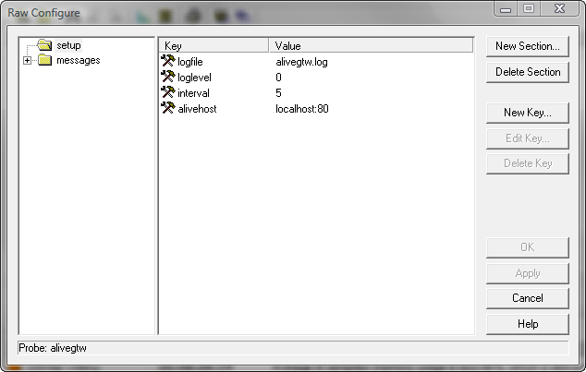

The following parameters are available in the “setup” section:

|  |  |
| --- | --- |
| * loglevel | The log level for the probe |
| * logfile | Log File name |
| * interval | The number of minutes in between each upload to Alive |
| * alivehost | The hostname or ip address and optional port number |

## Messages

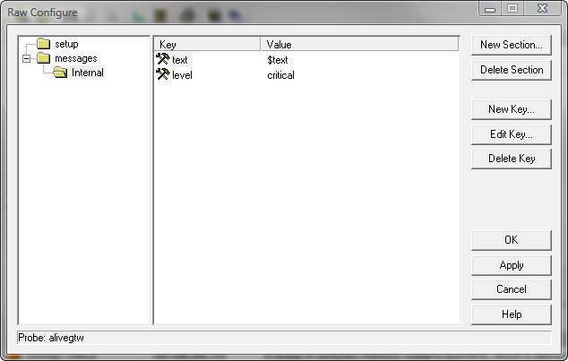

The following parameters are available for each message:

|  |  |
| --- | --- |
| * text | The format of the text. There are 1 variable values:  $text – the name of the function/command that has failed. |
| * level | The severity for the alarm (clear, info, warning, minor, major & critical). |

**Defining the Hub Queue**

You need to define an attach hub queue named “alivegtw” for subject of QOS_MESSAGES:

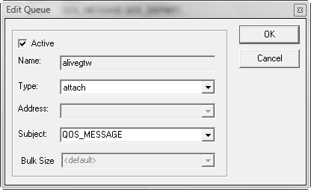

**Installing the LWP Perl Module**

Installing the LWP Perl module is done through “shell”.

You can test to see if you have LWP installed by typing:

perl -MLWP -le "print(LWP->VERSION)"

If you get something like: **Can’t locate LWP.pm in @INC**means that you don’t have it installed. To install LWP, type:

perl -MCPAN –eshell

NOTE: most times it is okay for you to accept default answers to questions cpan asks.  
You can read through cpan help by typing “h” without the quotes at cpan> prompt.  
To continue installing LWP, type:

install Bundle::LWP